Cupcake Decorating Made Easy

This is an introduction to cupcake decorating: you will learn how to tint icing, fill a decorating bag, fill a cupcake and pipe a variety of decorations, including the popular 1M swirl and Drop Flowers. You’ll take home your decorated cupcakes to share with family and friends.

Cupcake Decorating Made Easy
Objective: Teach basic skills for cupcake decorating
Recommended Ages: Teen to adult
Time Required: 3 hours

Overview: Students will learn simple hints and techniques for baking and decorating amazing cupcakes.

Class Outline:
- Baking Basics
  - Batter
  - Baking Cups
  - Filling
  - Baking Hints
- How to Prepare a Decorating Bag
- Icing Techniques
  - Smooth Ice
  - Swirl
- Color techniques
  - Color Icing
  - Bag Striping
  - Spatula Striping
- Basic Piping
  - Zigzag
  - Star
- Flowers
  - Star Drop Flower
  - Swirl Drop Flower
Clean up

Cupcake Decorating Made Easy
Student Supply List
Wilton Products (can be purchased at Michaels, Jo-Ann Fabrics, Walmart, Amazon)
- 9-inch angled spatula
- Gel Icing Colors
- Cupcake Decorating Set (must contain tips 2D, 4B, 1M, 2A) plus disposable decorating bags
- Option 1: Purchase a 4 lb. Tub Wilton White Creamy Decorator Icing (regular icing is too soft for decorating)
- Option 2: Two recipes of the following homemade class buttercream icing. Follow this site for the recipe and directions: https://www.youtube.com/watch?v=EWEhHhcnwYQ
Items from Home
- Apron
- 12 cupcakes
- 3 medium size bowls (2 cups ea.) for coloring icing
- Container to bring cupcakes home (or) cupcake pan
- Jam or pudding (for cupcake filling)
- 1 Gallon size plastic bag (for leftover icing)

Cupcake Decorating Made Easy

Session Summary

Cupcake Baking Basics – 10 min

Filling Cupcakes – 5 min

Preparing Decorating Bags - 8 min.

How to color icing – 10 min

Three Essentials of Decorating – 15 min

How to ice cupcakes with spatula and smooth them – 15 min

Two-Tone Frosting/Spatula Striping bags – 10 min

Two-Tone Swirl – 10 min

1M Swirl Cupcake– 10 min

Brush Striping bags – 10 min

2A Swirl Cupcake– 10 min

Zigzag – 10 min

Star – 10 min

2D Star Drop Flower and Star Flower Cupcake – 15 min

2D Swirl Flower and Hydrangea Cupcake – 15 min

Clean up – 15min

Cupcake Decorating Made Easy

Cupcake Baking Basics

Preparing the Batter
- Generally, most cake recipes or mixes will work for cupcakes. Simply adjust the baking time for the smaller portion.
- Proper measuring of ingredients is key to perfectly baked cupcakes-especially when you’re making them from scratch.
- Time the mixing carefully, beating only for the length of time and at the mixer speed specified in recipe instructions.
- For best results, and moister cupcakes, use large-size eggs (about ¼ cup each).

Note: Cupcakes tend to go stale quickly. If you add 1 tsp. glycerin, which serves as a humectant (preserving moisture) to the batter before baking, it will help to retain the moisture and give you an extra day or two of life on your cupcakes.

Preparing the Baking Pan

Cupcakes are traditionally baked in a paper or foil baking cups but can also be baked right in muffin pan cavities without a cup.

Baking with Cups: For perfectly shaped cupcakes, place your cups in muffin pan cavities and check that cups are level before filling.

Baking Without Cups: Prepare pan cavities by spraying with a non-stick spray or non-stick vegetable pan spray.

Filling Cups with Batter

One of the biggest challenges that cupcake bakers have is finding a way to fill each baking cup with the same amount of batter, so their cupcakes are all a consistent height.
- Traditional methods: spoons, ice cream scoops, squeeze bottles, measuring cups
- Alternative methods: Wilton Scoop-It Batter Spoons, Wilton Perfect Fill Batter Dispenser.

-1-

Baking Hints
  - Inaccurate oven temperatures account for most baking problems. Use an oven thermometer to check for accuracy.
  - Bake your cupcakes immediately after mixing the batter. Letting batter stand can cause some of the air you’ve beaten in to escape and your leavening isn’t as effective, making for a denser baked treat.
  - Place muffin pan as near to the center (both vertical and horizontal center) of the oven as possible. Make sure the oven rack is level.
  - Time your baking accurately. If you are baking in several pans at a time, you may need to add a few minutes to baking time.
  - Test your cupcakes for doneness while they’re still in the oven. A cupcake that is done will spring back to its shape when touched in the middle.
  - Cool cupcakes in the pan on a cooling grid for 5 minutes before removing
  - Cool completely on a cooling grid before filling and icing.

Filling Cupcakes

Filling a Cupcake Using a Bismarck tip #230:
    - Insert tip into the top center of a cupcake
    - Squeeze with light pressure, slowly pulling tip up and out of the cupcake
    - Stop pressure and pull tip away
    - Will work for any smooth filling like custard, pudding, cream

Coring a Cupcake
    - A corer is used when you want to put something chunky inside a cupcake and you need to remove the cake to make space for the filling; i.e. nuts, mini candy, fruit
    - Alternative method: insert wide end of a large tip of your choice into center of cupcake. Lightly push down until tip is about 2/3 into cupcake. Remove tip and fill hole with filling.

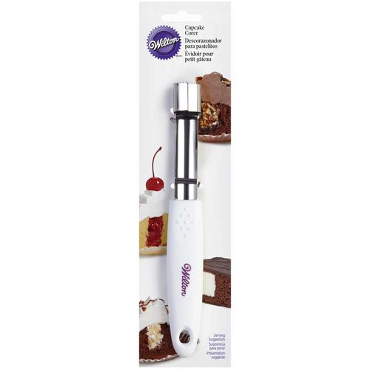

Preparing a Decorating Bag

Simply drop the tip into an uncut bag. Push tip all the way into the bag as far as it will go. Look for the top and the bottom of the tip, and mark bag half way on the tip. Slide tip back out of the bag and cut point off. Place tip back in bag and make sure that the opening of the tip is not covered by the bag. If the opening is covered, slide tip out and trim bag point a little more. Be sure to push decorating tip firmly into bag to ensure icing does not leak from bag point.

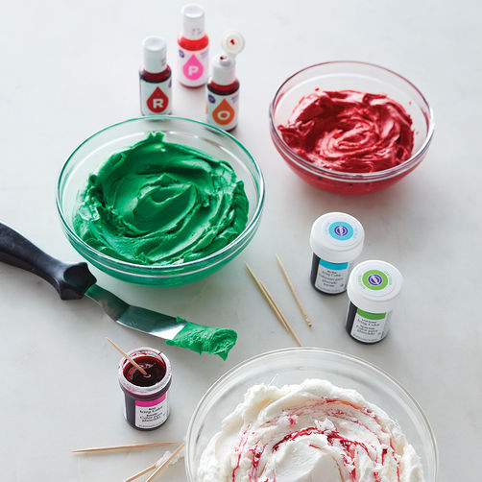How to Color Icing

Step 1
Although several food coloring options are available, gel-based food colors, such as Icing Colors or the Color Right Performance Color System, are recommended for coloring icing. Unlike liquid food coloring, gel-based colors are concentrated and will not affect the consistency of the icing, especially when it comes to bright or rich colors for which more coloring is needed to achieve the desired effect. Gel-based colors are also ideal for situations where adding extra liquid can cause issues, such as coloring sensitive batters like meringues or macarons.
Icing Colors can also be used to tint cake batter. Colored batter bakes lighter, so tint a shade darker than needed. Tinting batter is most successful with white cake because egg yolks will add a yellow tint.
Hints for Coloring Icing:
- If using Wilton Icing Colors, dip a toothpick into the color and swipe against the icing. Always use a fresh toothpick to add more color to avoid contaminating the icing color. If using Color Right, squeeze drops of color directly onto the icing.
- A little goes a long way. Try adding only a little at a time and mix to check whether you’ve achieved the right shade. When coloring buttercream icing, remember that colors intensify or darken after a few hours.
- Colors are very hard to duplicate, so keep the size of your project in mind and mix as much icing as you’ll need to finish it.

-3-
Hints for Bright or Deep Colors:
- Allow deep colors to set up for a few hours or even overnight — colors will deepen as they set.
- If adding a large amount of icing color to achieve a vibrant hue, consider using the tip of a butter knife to add color instead of using toothpicks.
- Start with a chocolate buttercream icing for dark colors such as black, brown or even brown-based reds. Not only will chocolate icing produce a better color, but it will also taste much better.
- Too much red color can affect the taste of the icing. For best results, use No-Taste Red Icing Color.
- If you only need a small amount of dark or bright icing, consider using Ready-to-Use Icing Tubes or Icing Pouches.

Three Essentials of Decorating

Icing Consistency:

Stiff: used to make three-dimensional decorations, such as flowers with upright petals like the rose.

Medium: used to make two-dimensional decorations, such as stars, shells, borders, rosettes, zigzags and flowers with flat petals like drop flowers.

Thin: used for decorations, such as printing, writing and leaves. Thin icing is also used for icing cakes.

Correct bag position (Holding the Bag)

90-degree angle is straight up, perpendicular to the work surface.

45-degree angle is halfway between vertical and horizontal.

Direction:

The angle of the bag to the work surface, when holding it at 45 degrees, is only half of the story of bag position. The other half is the direction in which the back of the bag is pointed. Correct bag position is easiest to learn when you think of the back of the bag as the hour hand of a clock. Hold the bag with the tip in the center of the clock, without moving the tip from that position, sweep out a circle with the back end of the bag. Pretend the circle you form in the air is a clock face. The hour on the clock face correspond to the direction you point the back of the bag.

Pressure Control (Squeezing the Bag)

The size and uniformity of your designs are affected by the amount of pressure you apply to the bag and the steadiness of the pressure-how you squeeze and relax your grip on the decorating bag. Your goal is to learn to apply pressure so consistently that you can move the bag in a free and easy glide while just the right amount of icing flows through the tip.

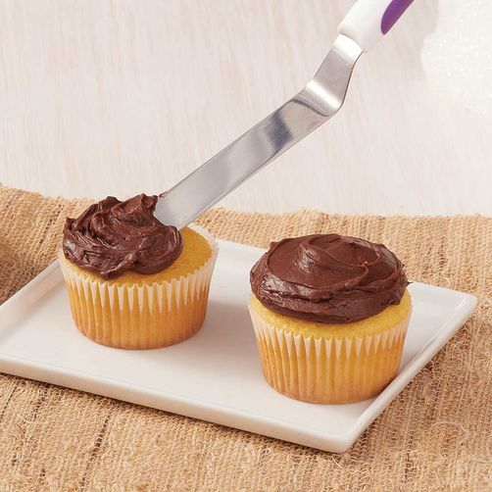 How to Frost Cupcakes with a Spatula

Step 1
Place a dollop of icing at the center of the cupcake.

Step 2
Spread icing across the top, pushing toward the edges. For a smooth look, run the spatula edge across the top. Let icing crust over, cover with a piece of VIVA paper towel, lightly rub the surface until smooth.

Step 3
For a fluffier look, lightly touch the iced surface with the spatula blade and lift up.

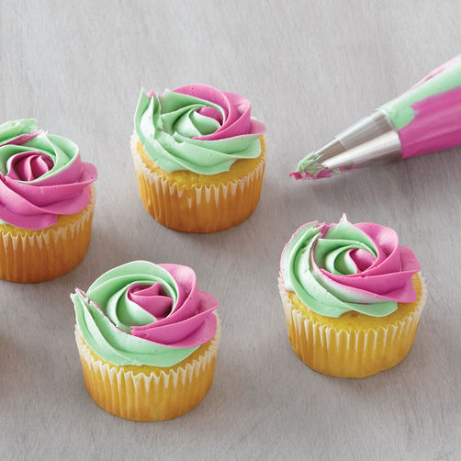Double Bag Swirl

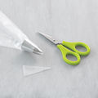Step 1
Prepare an empty 16-inch or 12-inch bag with a tip, (we recommend using large tips such as Tips 1M, 2D, 2A or 789).

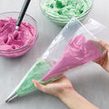Step 2
Fill two 12-inch bags separately with icing colors of your choice. Be careful not to overfill the bags. Cut the tips off the bags and place both bags inside the prepared decorating bag. Twist and secure the tops of all the bags.

-6-

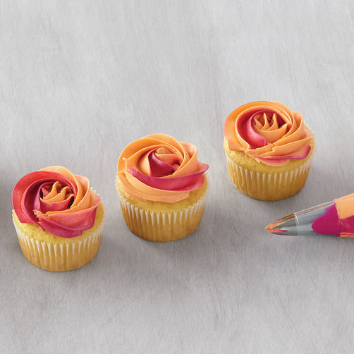Spatula Striping

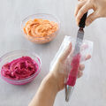Step 1
Prepare two colors of buttercream — one base and one accent color (prepare less of the accent color). Dip an Angled Spatula into the accent color and smear the icing upward inside the decorating bag.

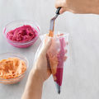Step 2
Carefully fill the bag with the base color buttercream, making sure not to smear the accent color.

-7-
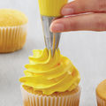How to Pipe a Cupcake 1M Swirl

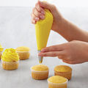Step 1
Using a decorating bag fitted with tip 1M, 2D or 2A, hold the bag straight up, with the tip about half an inch above the surface of your cupcake.

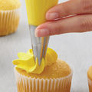Step 2
Squeeze to form the center of the swirl. Without releasing pressure, raise the tip a little bit and move it slightly to the side. This will be the starting point of your swirl.
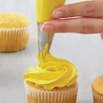Step 3
Pipe a line of icing toward the top of the star. Using a circular motion, pipe a “C” until it connects to the starting point.

Step 4
After completing the first rotation, move the tip slightly inward and repeat the circular motion. Continue spiraling until you reach the desired height. End the spiral at the center of the cupcake. Stop squeezing before pulling tip away.

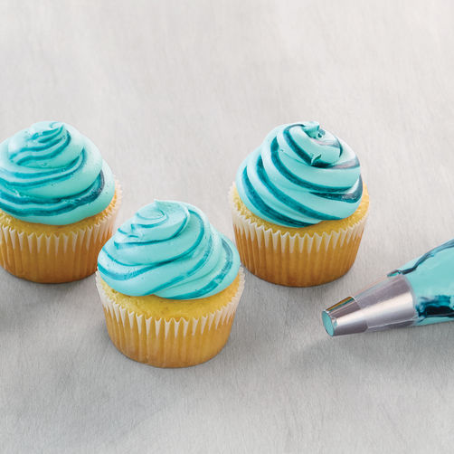 Brush Striping

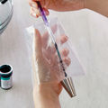Step 1
Dip a decorating brush in Icing Color and paint vertical stripes inside the decorating bag. For extra color you can add more stripes, making sure stripes don’t bleed together in the bag.

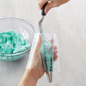Step 2
Carefully fill the bag with the base color buttercream, making sure not to smear the colored stripes in the bag.

-9-

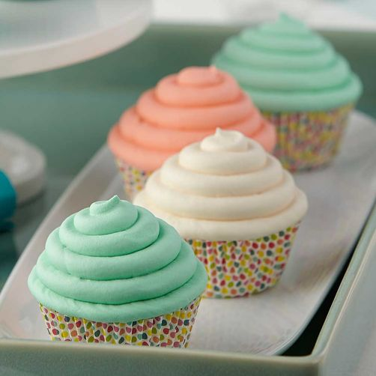How to Make Round Tip 2A Swirl

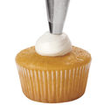Step 1
Hold decorating bag straight up. Pipe a mound of icing in the center of the cupcake. As the icing begins to build up, raise the tip with it, but keep the tip end buried in the icing.

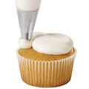Step 2
Squeeze as you move tip counterclockwise around the mound.

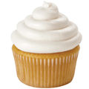Step 3
Continue squeezing in a counterclockwise motion for four turns or until completed. Lift tip up and away to create a peak at top.
-10-

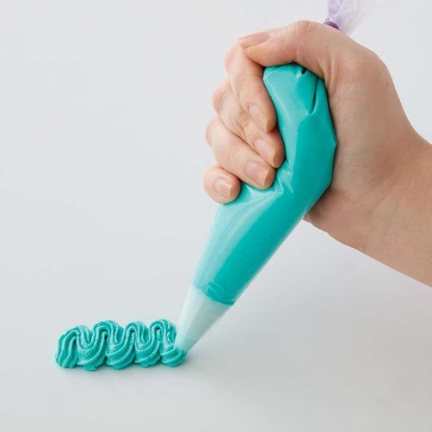How to Pipe a Zig Zag

Step 1
Lightly touch the surface with the tip.

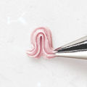Step 2
Steadily squeeze and glide tip along the surface in an up and down motion.

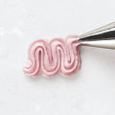Step 3
Continue piping up and down with steady pressure. To end, stop pressure and pull tip away. For more elongated zigzags, move your hand to the desired height while maintaining a steady pressure. For a more relaxed look, increase the width as you move the bag along the surface.

Step 4
Hint: When piping zigzags, think about two motions simultaneously. The movement of your arm determines the height of the waves and the distance between them. The pressure on your bag determines the thickness of the line. Strive for uniform thickness and even spacing as you go.

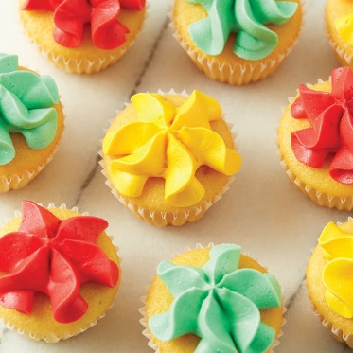How to Pipe a Star

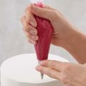Step 1
Using a decorating bag fitted with a star tip, hold the bag straight up, with the tip just slightly above the surface.

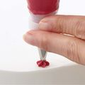Step 2
Squeeze the bag to form a star. Use light pressure to form a small star; add more pressure to make a bigger star.

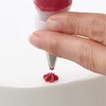Step 3
Stop squeezing before pulling tip away.
Step 4
To create a pull-out star, form the star, then continue squeezing and pull tip up and away. Decrease pressure as you reach the desired length.
Hint: See your project instructions for the correct size tip to use.
- For a small star, try using Tip 13
- For a larger standard star, try using Tip 22
- For an extra-large star, try using tip 1M or 4B

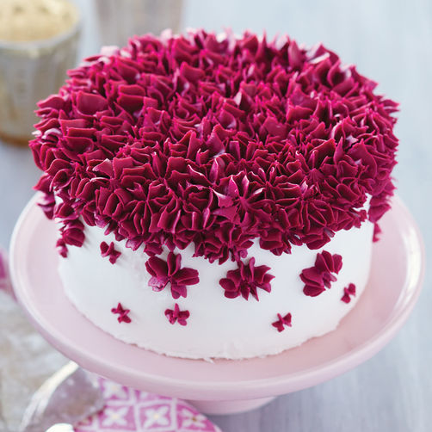How to Pipe a Star Drop Flower

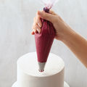Step 1
Using a decorating bag fitted with tip 2D, hold the bag straight up, with the tip just touching the surface.

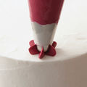Step 2
Squeeze and let the icing build to form a flower. Use light pressure to form a small flower; add more pressure to form a bigger flower.

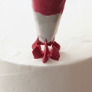Step 3
Stop squeezing before pulling tip away. Pipe a center if desired using tip 2, 8 or 18.

-13-

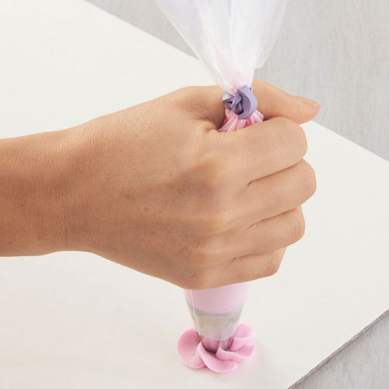How to Pipe Swirl Drop Flowers

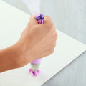Step 1
Using a decorating bag fitted with tip 2D (drop flower tip), hold the bag straight up, but bend your wrist inward.

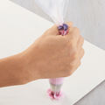Step 2
With the tip just touching the surface, squeeze out icing.

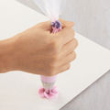Step 3
As you squeeze, turn your wrist outward.

Step 4
Stop squeezing before pulling tip away. Pipe a center if desired using tip 2, 8 or 18.
Instructors Supply List
- Cupcakes
- Icing
- 9” angled spatula
- Paint brushes
- Plastic bowls (to color icing)
- Tips (2D, 4B, 1M, 2A, Bismarck 230)
- Disposable decorating bags
- Toothpicks
- Viva paper towels
- Icing colors
- Elastic bands
- Tape
- Plastic Placemats

